**PYTHON PROJECT ~ 1**

# AIM OF THE PROJECT:-

* The Aim of this project is to write and test a code for making a live weather app in Python Programming Language.

# OBJECTIVE OF THE PROJECT:-

* The main objective of this project is to fetch the weather of a place at that lively time through a Python Code.
* The place for which the weather report should be fetched will be given by the user as user input.
* The way of doing this is to import a live database from a live weather map and providing the ways to the user for requesting various datas of that particular place. Eg; Wind speed, Humidity, Chances of rain (Precipitation), ect.

# CODE FOR THE PROJECT:-

def find_weather(city_name):

city_name = city_name.replace(" ", "+")

try:

res = requests.get(

f'https://www.google.com/search?q={city_name}&oq={city_name}&aqs=chrome.0.35i39l2j0l4j46j69i60.6128j1j7&sourceid=chrome&ie=UTF-8', headers=headers)

print("Loading...")

soup = BeautifulSoup(res.text, 'html.parser')

location = soup.select('#wob_loc')[0].getText().strip()

time = soup.select('#wob_dts')[0].getText().strip()

info = soup.select('#wob_dc')[0].getText().strip()

temperature = soup.select('#wob_tm')[0].getText().strip()

print("Location: " + location)

print("Temperature: " + temperature + "&deg;C")

print("Time: " + time)

print("Weather Description: " + info)

except:

print("Please enter a valid city name")

city_name = input("Enter City Name: ")

city_name = city_name + " weather"

find_weather(city_name)

# OUTPUT BY THE CODE:-

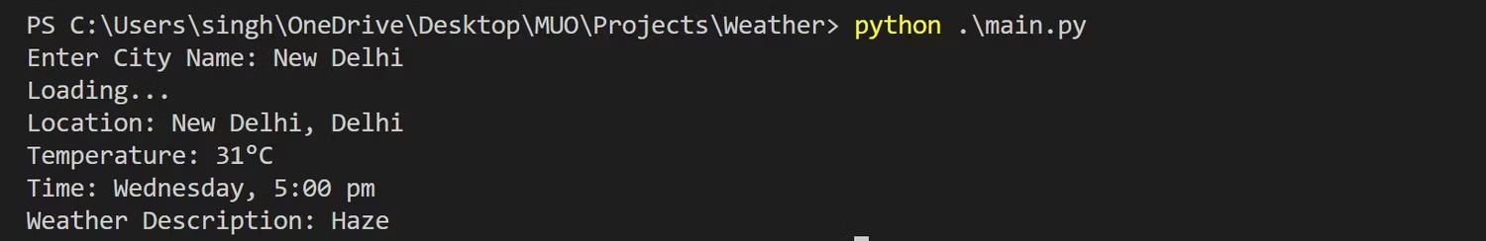

# CONCLUSION:-

* Therefore ,by getting the place\City`s name as an input fro the user, we have successfully provided all the providable information about that particular place’s weather condition.

**X-X-X-X-X-X-X-X-X-X-X-X-X-X**